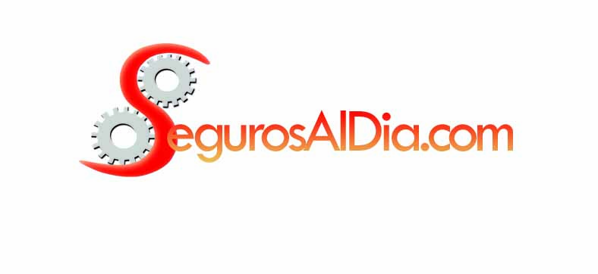
31/03/2017 ART VENTAS

 | COMPAÑÍA | RANKING DE PRIMAS EMITIDAS | PARTICIPACIÓN %
1 | PREVENCIÓN ART | 10.945.418.003 | 20,57%
2 | PROVINCIA ART | 9.951.526.230 | 18,70%
3 | GALENO ART | 8.833.697.343 | 16,60%
4 | EXPERTA ART | 7.067.930.036 | 13,28%
5 | ASOCIART ART | 5.158.766.723 | 9,70%
6 | SEGUNDA ART | 4.255.573.639 | 8,00%
7 | SWISS MEDICAL ART | 3.981.220.335 | 7,48%
8 | OMINT ART | 1.304.136.511 | 2,45%
9 | BERKLEY ART | 892.486.701 | 1,68%
10 | LIDERAR ART | 426.238.333 | 0,80%
11 | CAMINOS PROTEGIDOS ART | 237.241.286 | 0,45%
12 | RECONQUISTA ART | 153.195.181 | 0,29%
 | TOTAL | 53.207.430.321 | 100,00%

